

**SLModes**  
Version 2.5.0

User Manual for macOS

**Introduction**

Thank you for purchasing SLModes. With this software, you can now easily explore the modes and chords of the Major, Melodic Minor, Harmonic Minor scales, among others, and find ways to freely jump between any of their modes.

**New in Version 2.5.0**

* Added the **Negative Harmony** section, which allows you to calculate negative modes and negative chords by mirroring the Circle of Fifths.

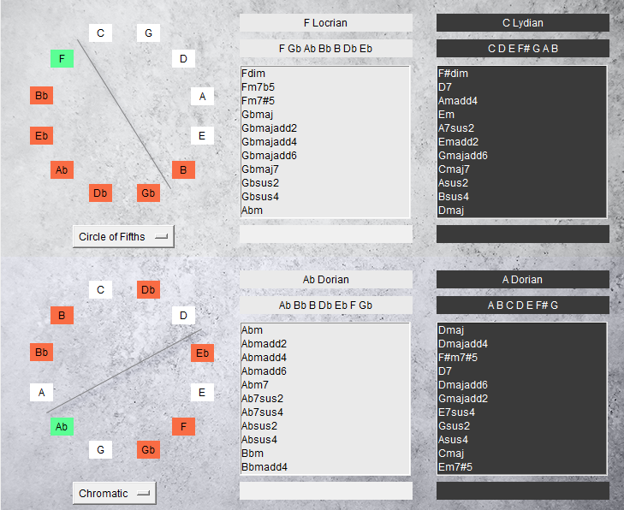

* Added *“Playing Styles”* to Composer Mode, allowing you playback the chord progressions not only as arpeggiated notes, but also as chords and chords + metronome.
* Added the button “Export MIDI” to Composer Mode
* Composer Mode now remembers your chord progression when you close and re-open its window.
* Added more realistic graphics to the **Extended Fretboard**.
* Added the possibility to “show the notes of the currently selected chords” in the **Extended Fretboard**, highlighting them in the colour blue.  
    
  Uma imagem com tecido

  Descrição gerada automaticamente
* Added 2 buttons to Composer mode to add chords directly from the Negative Harmony section.
* Added Preset buttons to the Settings window, to Enable / Disable scales and chords more easily.
* Added Keyboard shortcuts:
  + Extended Fretboard
    - Show / Hide Chord Notes: **C**
  + Composer Mode
    - Add Mode Chord 1: **1**
    - Add Scale Chord 1: **2**
    - Add Mode Chord 2: **3**
    - Add Scale Chord 2: **4**
    - Add Negative Chord 1: **5**
    - Add Negative Chord 2: **6**
    - Remove: **BackSpace**

**System Requirements**

**Operating System:** Catalina / Big Sur

**Architecture:** 64 bits  
**RAM:** 1GB

**Soundcard:** Required for audio playback

**Hard-Drive Free Space:** 500 MB

**Screen Resolution:** 980x600

**Installation Guide**

**1.** Since SLModes was not validated by Apple, macOS will try to prevent you from opening it the first time you try to do it.

This can be solved in 6 clicks.

Follow the instructions exactly as written:

1. Right-Click the *SLModes.app* icon

2. Click *Open.* A message appears (Figure 1)  
3. Click *Cancel*  
4. Right-Click the *SLModes.app* again

5. Click *Open*. A new message appears (Figure 2), now showing you the option to Open the app.

6. Click Open. From now on, SLModes will always open without any warnings.

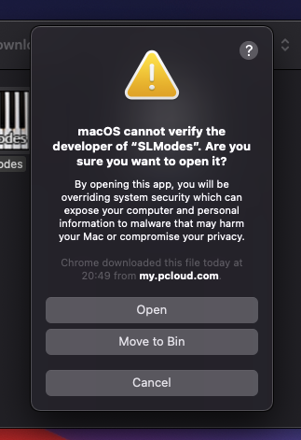

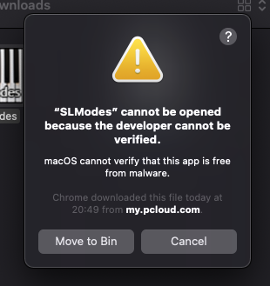

Figure 1

Figure 2

**Main Window**

SLModes is comprised of two sections (left and right).

On the left, you can select a mode to explore. Once you do that, a list of matching modes based on the number of notes in common is automatically calculated and displayed on the right portion of the software.

|  |  |
| --- | --- |
| **1** | Root note of the mode. |
| **2** | Shows all the modes of the scales you have selected in the *Settings*. |
| **3** | Shows the most relevant chords that you can extract out of the selected mode. Clicking on a chord will playback the chord and the notes of the mode. |
| **4** | The notes of the selected chord. |
| **5** | These are all the chords that can be extracted from the selected scale/mode, and not just the most relevant ones. |
| **6** | The notes of chord selected in the box **5**. |
| **7** | Shows the mode shape on a guitar neck. |
| **8** | Shows the mode shape on a piano. |
| **9** | The notes of the selected mode. |
| **10** | Opens a new window that shows the modes selected in box **2** and **15** across the entire guitar fretboard. |
| **11** | Opens a new window that allows you to write down chord progressions, play them in a loop, and export a MIDI file. |
| **12** | Opens a new window that shows you the negative harmony of the selected scales/modes. |
| **13** | Filter #1: only shows matching modes that contain the selected number of notes in common. |
| **14** | Filter #2: filters down the matching modes even further by showing only those that have the notes you specify in this field.   * This field is optional. * Always make sure you type the notes names correctly. * Separate the notes by a space, not commas. * This search box is not case-sensitive (you can type *A* or *a*) * For a sharp notation, use the symbol # * For a flat notation use the symbol b.   Enharmonically equivalency is taken care of (you can type Ab or G#) |
| **15** | A list of modes that match with the mode you choose with field **1** and **2** and filtered based on the field **13** and **14**. |
| **16** | Shows the most relevant chords that you can extract out of the selected matched mode. Clicking on a chord will playback the chord and the notes of the mode. |
| **17** | The notes of the selected chord. |
| **18** | These are all the chords that can be extracted from the selected matched scale/mode, and not just the most relevant ones. |
| **19** | The notes of chord selected in the box **18**. |
| **20** | Shows the mode shape on a guitar neck. |
| **21** | Shows the mode shape on a piano. |
| **22** | The notes of the selected mode. |

**Settings**

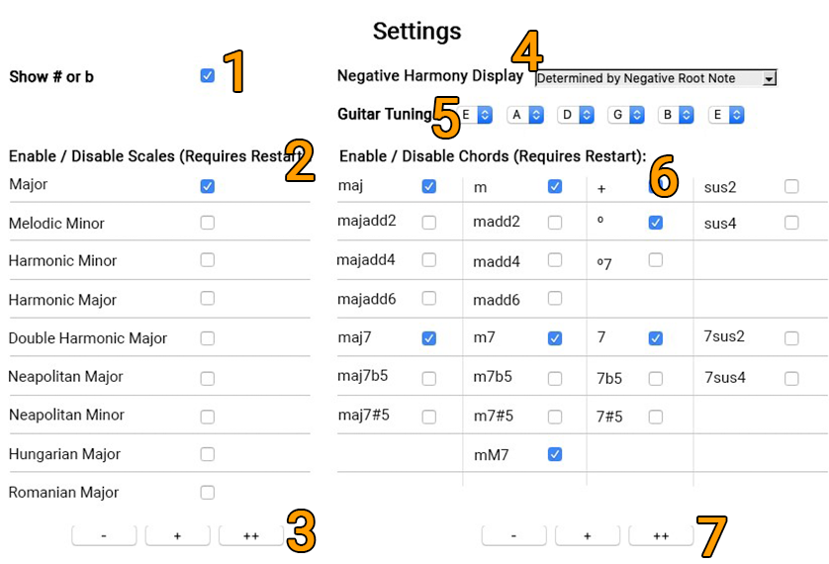

|  |  |
| --- | --- |
| **1** | Shows a **b** instead of a **#** accidental. |
| **2** | Choose up to 9 scales and their respective modes (a total of 63). You may choose just the scales you’re interested in, to simply or declutter the results list. As of now, changing these settings will require you to restart SLModes for them to have an effect. |
| **3** | 3 presets for selecting scales in **4**: Minimal (-), More (+), All (++) |
| **4** | When calculating the negative harmony of a scale/mode, there seems to exist two different approaches when naming the resulting negative scale/mode:  Using the C Ionian mode as an example:  The notes of the mode become: **C** D E F G A B C *(C Ionian)* → **G** Ab Bb C D Eb F *(G Phrygian)*  But the primary accompanying chord becomes: C maj (C Ionian) → C min (C Aeolian)  So, the negative harmony of C Ionian can be either G Phrygian or C Aeolian, depending on the criteria we choose:   * If the naming scheme is **determined by the negative root note,** then C Ionian becomes G Phrygian. * If the naming scheme is **determined by the resulting negative chord**, then C Ionian becomes C Aeolian.   But keep in mind: G Phrygian and C Aeolian both belong to the C Minor Scale, so, this option will not affect the results in any practical way, only how they are named. More specifically, they will only affect the naming scheme of the box **7** and **17**in the **Negative Harmony Window.** |
| **5** | Tune the individual strings of the *extended fretboard*. |
| **6** | Choose up to 25 chords, which cover all 3 and 4-note chords that can be formed. You may choose just the chords you’re interested in, to simply or declutter the results list. As of now, changing these settings will require you to restart SLModes for them to have an effect. |
| **7** | 3 presets for selecting chords in **6**: Minimal (-), More (+), All (++) |

**Negative Harmony**

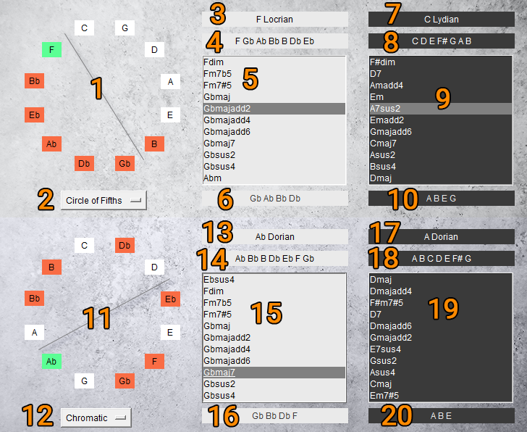

|  |  |
| --- | --- |
| **1** | Circle of Notes for the selected mode in box **1** and **2** situated in the **Main Window.**  The green box indicates the root note of that mode. The red boxes indicate the other notes of the mode.  Astraight line is drawn across this circle, using the root note as a reference, splitting the circle in two symmetrical parts.  Then, Negative Harmony is calculated by transforming the notes in the green and red boxes into their mirrored boxes across the line. |
| **2** | You can choose to turn the Circle of Notes into a:   * Circle of Fifths * Circle of Fourths * Circle of Seconds   No other intervals are available because these three are the only ones that can fill the twelve boxes without any note repeating.  Negative Harmony works best with the Circle of Fifths because it allows the negative chords to maintain the same tension as the original. However, other options were included for the sake of experimentation. |
| **3** | Shows the mode selected in the box **1** and **2** situated in the **Main Window.** |
| **4** | Shows the notes of the mode in box **3**. |
| **5** | Shows the chords belonging to the mode in box **3**. Double clicking the selected chord will play it. |
| **6** | Shows the notes of the chord selected in box **5**. |
| **7** | Shows the name of the negative mode of the mode in box **3**.  Depending on the option you selected in the box **4** in *Settings* *(***determined by the negative root note** or **determined by negative chord***),* this will show a different name. However, this only affects the naming scheme, not the results. No other box is affected by this *Settings* option. |
| **8** | Shows the notes of the negative mode in box **7**. |
| **9** | Shows the chords belonging to the negative mode in box **7**. Double clicking the selected chord will play it. |
| **10** | Shows the notes of the negative chord selected in box **9**. |
| **11** | Circle of Notes for the selected mode in box **15** situated in the **Main Window.**  The green box indicates the root note of that mode. The red boxes indicate the other notes of the mode.  Astraight line is drawn across this circle, using the root note as a reference, splitting the circle in two symmetrical parts.  Then, Negative Harmony is calculated by transforming the notes in the green and red boxes into their mirrored boxes across the line. |
| **12** | You can choose to turn the Circle of Notes into a:   * Circle of Fifths * Circle of Fourths * Circle of Seconds   No other intervals are available because these three are the only ones that can fill the twelve boxes without any note repeating.  Negative Harmony works best with the Circle of Fifths because it allows the negative chords to maintain the same tension as the original. However, other options were included for the sake of experimentation. |
| **13** | Shows the mode selected in the box **15** situated in the **Main Window.** |
| **14** | Shows the notes of the mode in box **13**. |
| **15** | Shows the chords belonging to the mode in box **13**. Double clicking the selected chord will play it. |
| **16** | Shows the notes of the chord selected in box **15**. |
| **17** | Shows the name of the negative mode of the mode in box **13**.  Depending on the option you selected in the box **4** in *Settings* *(***determined by the negative root note** or **determined by negative chord***),* this will show a different name. However, this only affects the naming scheme, not the results. No other box is affected by this *Settings* option. |
| **18** | Shows the notes of the negative mode in box **17**. |
| **19** | Shows the chords belonging to the negative mode in box **17**. Double clicking the selected chord will play it. |
| **20** | Shows the notes of the negative chord selected in box **19**. |

**Composer Mode**

|  |  |
| --- | --- |
| **1** | Adds the selected chord from the box **3** situated in the **Main Window**. *Keyboard Shortcut: 1* |
| **2** | Adds the selected chord from the box **5** situated in the **Main Window**. *Keyboard Shortcut: 2* |
| **3** | Adds the selected chord from the box **16** situated in the **Main Window**. *Keyboard Shortcut: 3* |
| **4** | Adds the selected chord from the box **18** situated in the **Main Window**. *Keyboard Shortcut: 4* |
| **5** | Adds the selected chord from the box **9**situated in the **Negative Harmony Window**. *Keyboard Shortcut: 5* |
| **6** | Adds the selected chord from the box **19**situated in the **Negative Harmony Window**. *Keyboard Shortcut: 6* |
| **7** | Chords added by buttons **1**, **2**, **3** and **4** are show here. |
| **8** | This field displays the music mode from which the chords were extracted from.  Chords added with the *Scale Chord 1* (**2**), *Scale Chord 2* button (**4**) and the Negative Harmony chords (**5**) and (**6**) will not display the original modes of those chords.   In this example, we know Am7 should show A Aeolian, and Fmaj should show F Lydian, but we should take into consideration the *context* of the chord progression:   * Since Am7 is used in the context of a C Ionian chord progression, it will display C Ionian. * Since Fmaj is being used in the context of a C Ionian chord progression, it will display C Ionian. |
| **9** | Move the selected chord in field **7** and **8** a position up. |
| **10** | Move the selected chord in field **7** and **8** a position down. |
| **11** | Removes the selected chord from field **7** and **8**. *Keyboard Shortcut: Delete* |
| **12** | Removes all chords from field **7** and **8**. |
| **13** | Plays the chords in **7** in a loop. It will start playing from whichever chord you have currently selected. |
| **14** | Stops playback |
| **15** | Saves the current chord progression in a .txt file on your computer. |
| **16** | Loads a .txt previously generated by SLModes, saved on your computer. |
| **17** | Sets the tempo of the playback. To do this, enter a valid number and the hit *Enter* tocommit the changes. |
| **18** | Select *Playing Style*:   1. Scale 2. Chord 3. Chord + Click |
| **19** | Export a MIDI file to your computer. This always uses the *Chord* playing style to export. |

**Keyboard Shortcuts**

|  |  |  |
| --- | --- | --- |
| Extended Fretboard | Show / Hide Chord Notes | **C** |
| Composer Mode | Add Mode Chord 1 | **1** |
| Composer Mode | Add Scale Chord 1 | **2** |
| Composer Mode | Add Mode Chord 2 | **3** |
| Composer Mode | Add Scale Chord 2 | **4** |
| Composer Mode | Add Negative Chord 1 | **5** |
| Composer Mode | Add Negative Chord 2 | **6** |
| Composer Mode | Remove | **BackSpace** |